Comparing Numbers

2 Player Activity
Materials: Playing cards (As-9s only), Greatest and Least Number spinner, comparing symbol cards

- Player 1, draw __________________ cards.

- Place the cards on one side of the circle.

- Player 2, draw __________________ cards.

- Place the cards on the other side of the circle.

- Use your greater than, less than and equal to symbols to compare the numbers.

- Spin the spinner to see which side gets a point (greatest number or least number)

- If your number wins, give yourself a point.

- Keep going until time is called.

Player 1 Points | Player 2 points

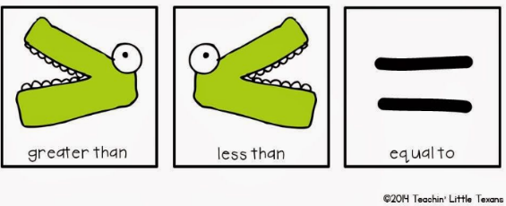
The player with the most points wins!

